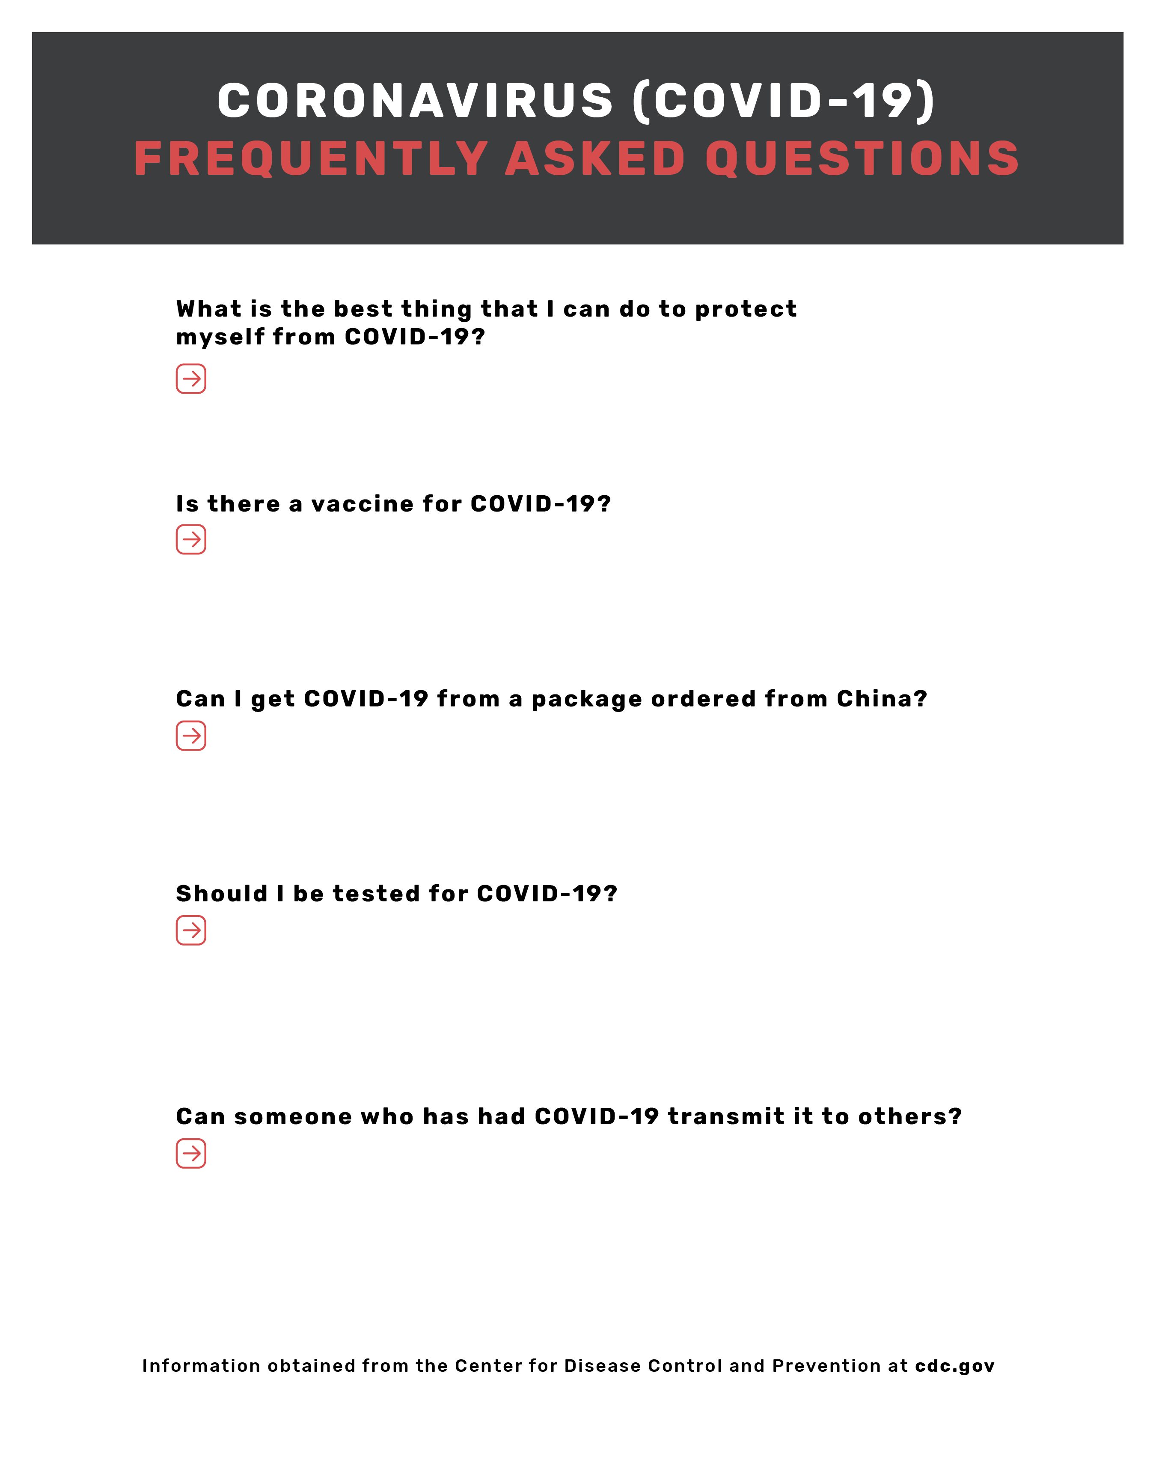

Someone who has been released from isolation is not considered to pose a risk of infection to others.

Call your healthcare professional if you feel sick with fever, cough, or difficulty breathing, and have been in close contact with a person known to have COVID-19, or if you live in or have recently traveled from an area with ongoing spread of COVID-19.

There is a very low risk of spread from products or packaging that are shipped over a period of days or weeks at ambient temperatures. The reason for this is because the virus can on survive on surfaces for 4-6 hours.

No, currently there is no vaccination for COVID-19

Wash your hands!

INSERT SCHOOL NAME HERE

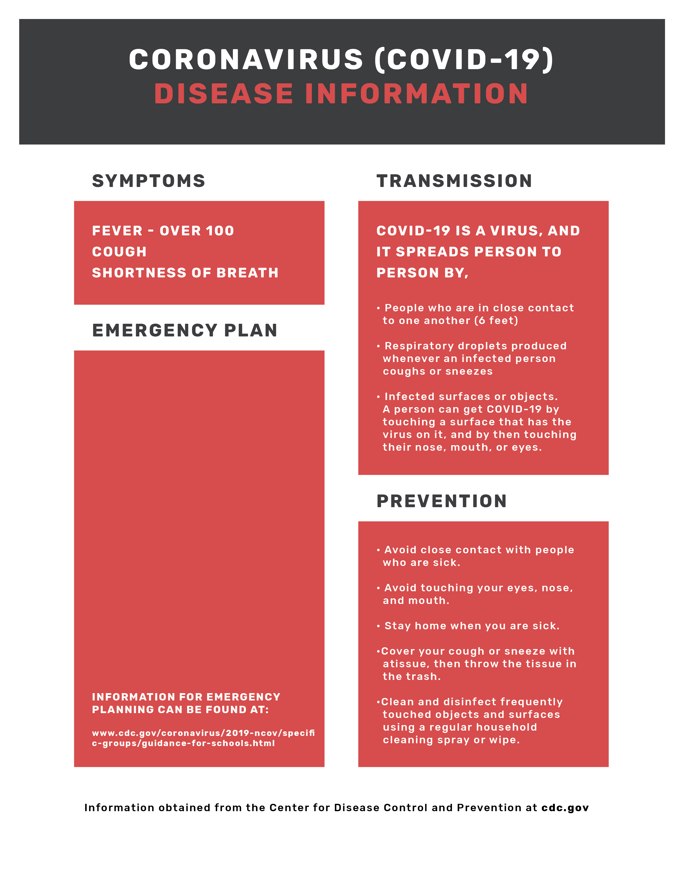

INSERT YOUR EMERGENCY OPERATIONS PLAN HERE



INSERT SCHOOL NAME HERE