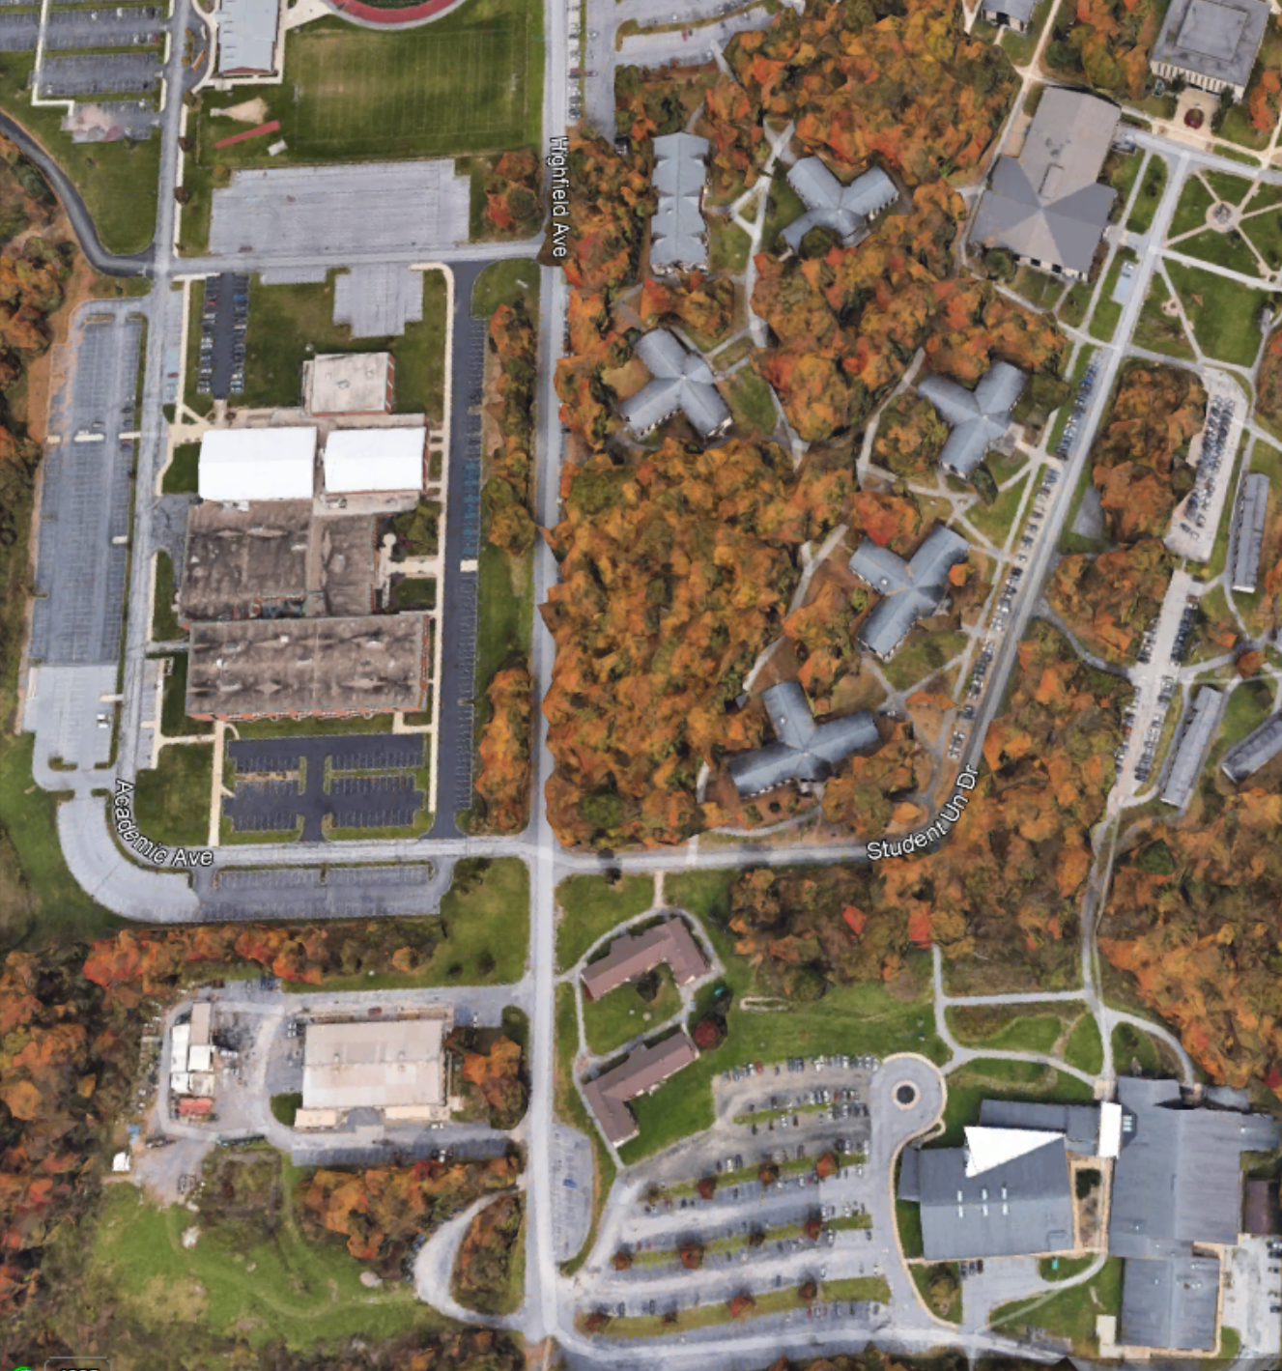

Volunteer & Vendor Parking

PARKING

PARKING

PARKING

PARKING



UPJ Sports/ Wellness Center



PARKING

Penn Highlands Community College