

HELP GUIDE FOR STUDENTS

How to Schedule a Tutoring Session

This document provides the information you need to schedule and attend a tutoring session.



**Pathways Navigate**

Access Pathways Navigate from

Pitt Mobile or My Pitt



**Find Program**

Find the tutoring program(s) you have access to, or email yourpitt@pitt

.edu about being added to a program.



**Schedule Session**

Find a tutor and look at your schedules to find a time you are both available.



**Email Confirmation**

Once you book a session, you will receive an email confirmation with appointment details.

**Tutoring Session**

Be on time for your in-person appointment.

# System Requirements

* Laptop or desktop computer
* Up-to-date Chrome browser (recommended)
* Up-to-date Firefox browser (alternative)
* Reasonable broadband connection (Internet connections, like those in coffee shops, are not recommended)

# Tutoring Programs and Resources

Visit **Tutor.pitt.edu** for a full list of tutoring programs and resources.



# Log in to Pathways Navigate

Log into the Navigate Student mobile app. Or in Chrome, go to my.pitt.edu/launch-task/all/pathways-navstudent and log in using PittPassport.

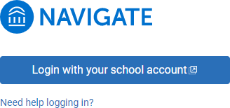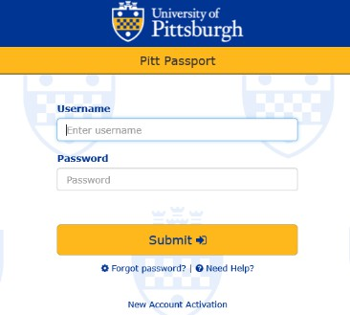

If you have trouble accessing either site, please contact [PathwaysHelp@pitt.edu](mailto:PathwaysHelp@pitt.edu) for assistance.

# How to Schedule a Tutoring Session

Click on the purple appointments icon on the Explore menu and click the blue Schedule an Appointment button to get started.

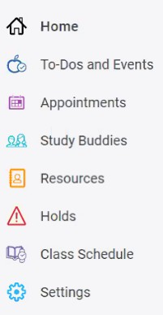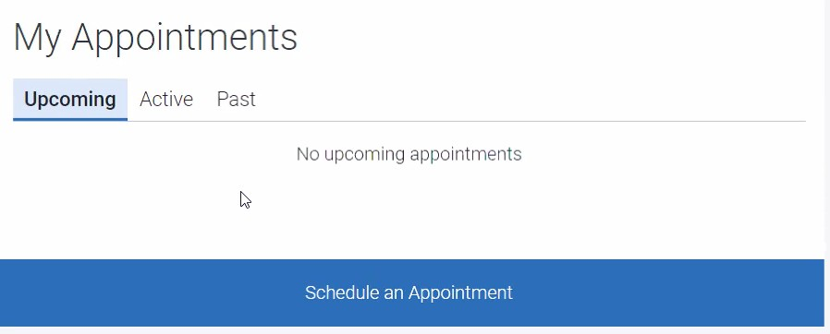

The next few screens will prompt you to choose what type of appointment you want (in this case, Tutoring), the school or campus, and the reason for your appointment.

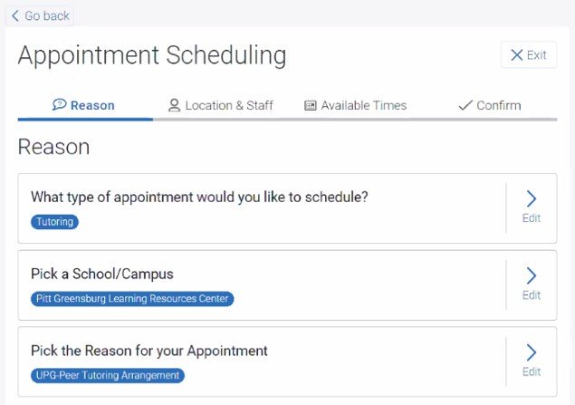

Choose a time for your tutoring appointment.

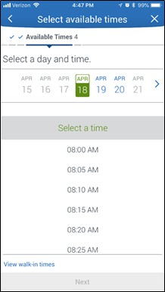

Confirm the appointment by clicking on the blue button at the bottom. A confirmation email will be sent to your Pitt email account.

