Objectives:
- Explain and demonstrate the importance of proper hand-washing technique (Activity 1).
- Explain the Coronavirus during the creation of the craft (Activity 2).

Activity 1
Introduction:
Teacher explains the importance of washing your hands, especially if you’re sick or in contact with people who are sick. You don’t want to be sick do you?

Procedure:
Have the students rub the glo gel thoroughly onto both sides of their hands. Make sure they get under their nails and in between fingers.

Have the students look at each other’s hands under a black light.
- Explain to the students that what they see glowing simulates the germs that are on their hands.
- Have student(s) touch a desk or doorknob to show the transfer of germs to everyday objects.
- Explain that if they were to touch this, they would “get someone else’s germs”.
Have Students rinse their hands with just water.
- Have them place their hands back under the black light.
- Explain to them that just washing with water is not enough to remove all of the germs.
- Have students re-apply glo gel
Have students wash their hands for 6 seconds with soap and water
- Have students place their hands back under the black light.
- Explain to students that even 6 seconds is still not enough time to get everything!
- Have students re-apply glo gel
Have students wash their hands for 20 seconds (or sing happy birthday twice) with soap and water,
- Instruct students to clean under their nails, and in between their fingers.
- Have the students place their hands under the black light one final time.
- Explain to the students the important of washing your hands for at least 20 seconds to make sure they get rid of all of the germs.

Activity 2

Introduction:
Teacher provides the students with a learning opportunity through creating a craft to represent the Coronavirus (COVID-19).

Procedure:
Pass out a total of the following for each student:
- Construction paper
- Paper plates
- Pipe cleaners
- Glue
- Colored pencils/markers
- Scissors
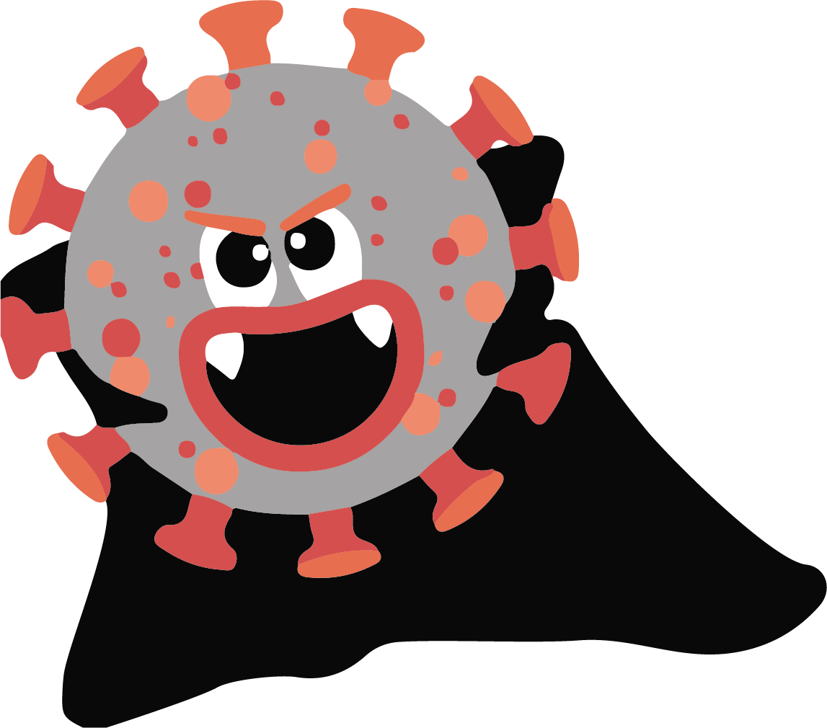
Have the students do their best to construct the image of count corona!

